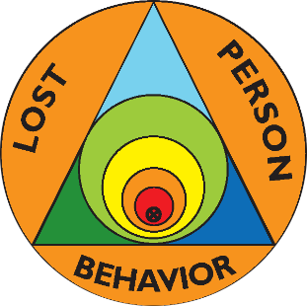 | Lost Person Behavior  Certification Class
Saturday, July 8, 2023
Illinois Fire Service Institute
11 Gerty Drive, Champaign, IL 61820
Class begins at 0800
Class ends by 1700

Presented by certified instructors Ralph & Ellen Kuchenbrod
All First Responders are invited and there are no prerequisites.

You must have the book or phone app, Lost Person Behavior by Robert Koester (the book is easier to use in class) plus the map exercises workbook. Lost Person Behavior is $30 and the workbook is $10. There is no charge for the class itself.
Registration is required by July 5. Fill out the registration form below, cut it off, and mail it along with a check made out to Ellen Kuchenbrod to 507 Deerpath St., Tolono, IL 61880. Questions? Contact Ralph Kuchenbrod at LNTsherpa@gmail.com or 217-778-1059.
Bring both your books if you already have them. Bring paper & a pen.

-------------------------------------------------------------------------------------------------------------------
Name _________________________________ Email ______________________________
Address ___________________________________ Phone __________________________
Agency you are affiliated with _________________________________________________
Lost Person Behavior Book (add $30 if needed) ___________
Map exercises book (add $10 if needed) ___________
Total Included: $ ____________

