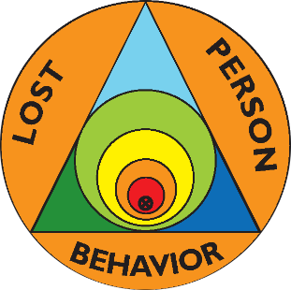 | Lost Person Behavior  Certification Class | 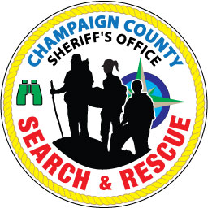
Saturday, June 15, 2024
Will County Sheriff’s Office
16911 W. Laraway Rd, Suite 101, 2nd floor
Joliet, IL 60433
Class begins at 0800
Class ends by 1700

Presented by certified instructors Ralph & Ellen Kuchenbrod
All First Responders are invited and there are no prerequisites.

You must have the book or phone app, Lost Person Behavior by Robert Koester (the book is easier to use in class) plus a map exercises folder (or the Practical Map Exercises workbook). Lost Person Behavior is $30 and the folder is $10. There is no charge for the class itself.
Registration is required by June 12. Fill out the registration form below, cut it off, and mail it along with a check made out to Ellen Kuchenbrod to 507 Deerpath St., Tolono, IL 61880. Questions? Contact Ralph Kuchenbrod at LNTsherpa@gmail.com or 217-778-1059.
Bring both your books if you already have them. Bring paper & a pen.

-------------------------------------------------------------------------------------------------------------------
Name _________________________________ Email ______________________________
Address ___________________________________ Phone __________________________
Agency you are affiliated with _________________________________________________
Lost Person Behavior Book (add $30 if needed) ___________
Map exercises folder (add $10 if needed) ___________
Total Included: $ ____________

