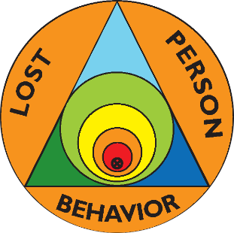 | Lost Person Behavior  Certification Class | 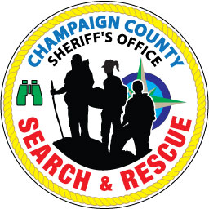
Saturday, November 2, 2019
Tolono Fire Department, 214 N. Bourne St., Tolono, IL 61880
Sign-in begins at 0800 and class starts promptly at 0830
Class ends at 1700 – Lunch will be provided – Cost $10

Presented by certified instructors Ralph & Ellen Kuchenbrod
All First Responders are invited and there are no prerequisites.

Two books are required in class, Lost Person Behavior by Robert Koester (you can have the phone app instead of the book) and Lost Person Behavior: Practical Map Exercises. Both are available on Amazon. You can also purchase books from us at $27 each. Coffee, donuts, fruit, & snacks will be available. Lunch will be provided.
Registration is required by October 20 so we can order books. Fill out the registration form below, cut it off, and mail it along with a check made out to Ellen Kuchenbrod to 507 Deerpath St., Tolono, IL 61880. Questions? Contact Ralph Kuchenbrod at LNTsherpa@gmail.com or 217-778-1059.
Bring your books if we are not purchasing them for you. Bring paper & a pen.
------------------------------------------------------------------------------------------
Name ________________________ Email __________________________
Address __________________________________ Phone ______________
Agency you are affiliated with ______________________
Class Fee (includes coffee, donuts, snacks, lunch, and supplies)---- $10.00
Lost Person Behavior Book (add $27 if needed)--------------------- __________
Lost Person Behavior: Practical Map Exercises (add $27 if needed) __________
Total Included: $__________

